Name : Kirtesh Satish Admute
Roll No. : 258039
PRN : 250841220082
Module : DBT

Create a Employee Collection add 5 documents:
Example:
{emono:111,ename:”Deepali
Vaidya”,sal:40000.00,dept:{deptno:12,dname:,”Hr”,dloc:”Mumbai},

Desg:”Analyst”,mgr:{name:”Satish”,num:111},project:[{name:”Project-
1”,Hrs:4},{name:”project- 2”,Hrs:4}]}


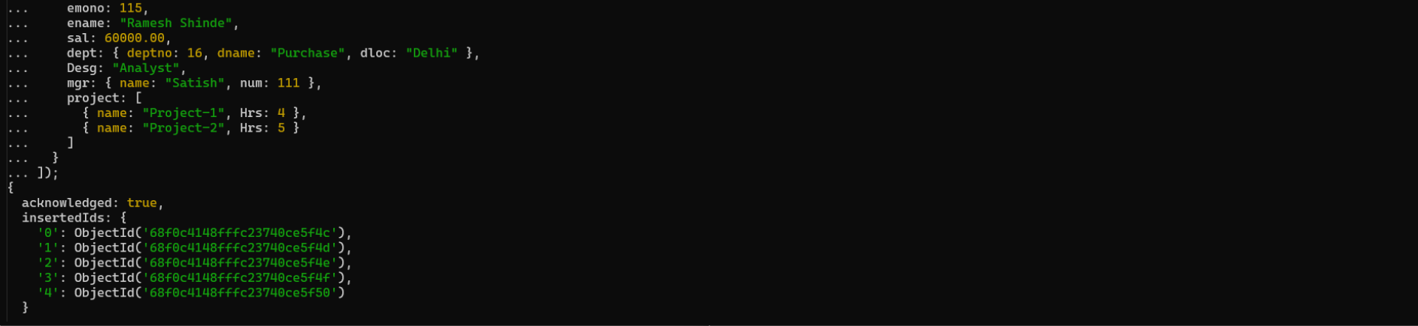
// 1. All Employee’s with the desg as ‘CLERK’ are now called as (AO) Administrative Officers.
Update the Employee collection for this.
db.emp.updateMany({ Desg: "Clerk" }, { $set: { Desg: "AO" } });
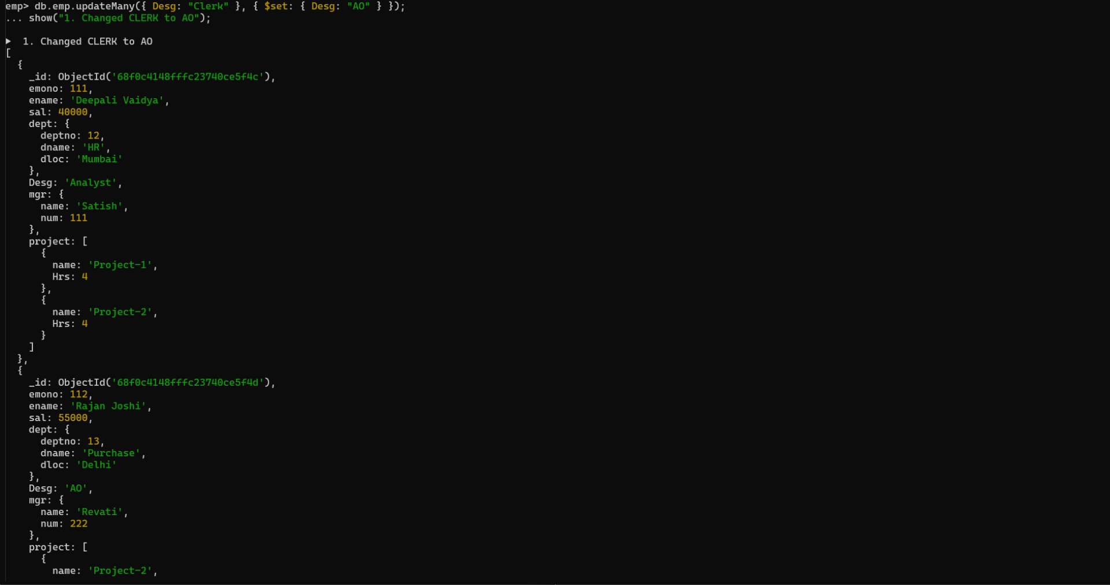

// 2. Change the number of hours for project-1 to 5 for all employees with designation analyst.
db.emp.updateMany(
{ Desg: "Analyst", "project.name": "Project-1" },
{ $set: { "project.$.Hrs": 5 } }
);
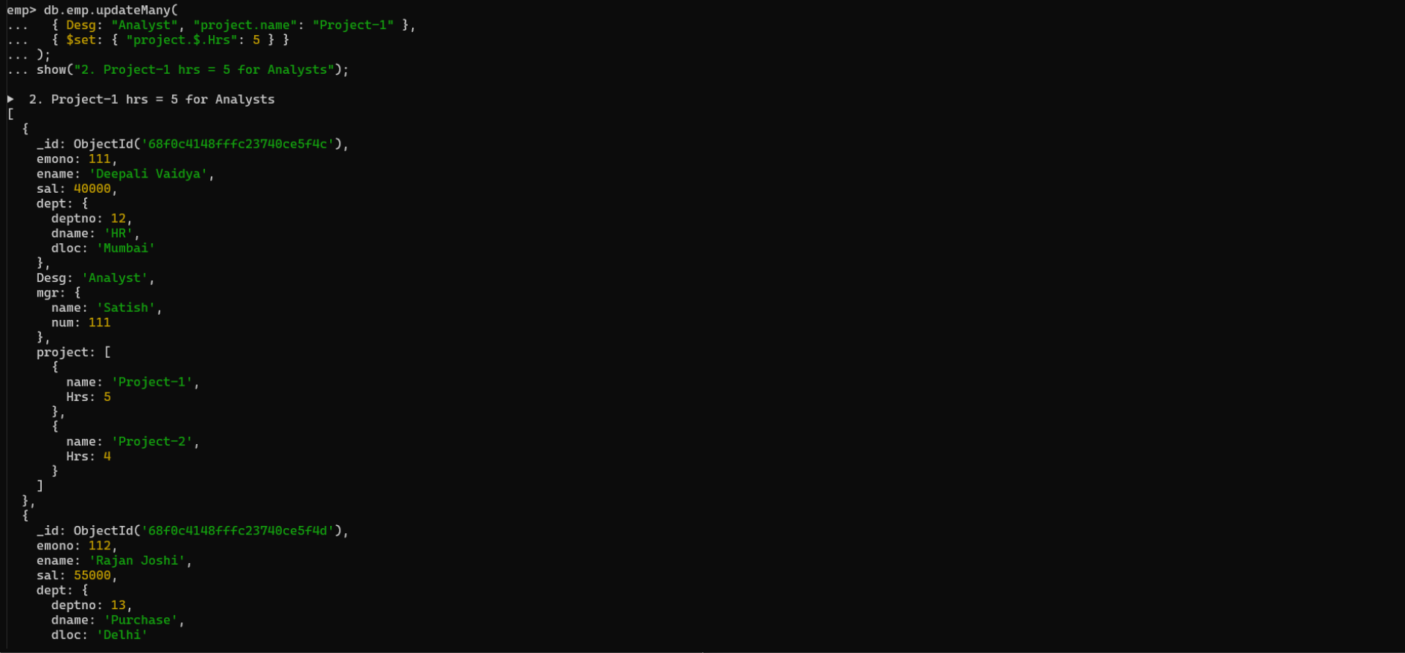

//3. Add 2 projects project-3 and project-4 for employee whose name starts with ”Deep” with 2 hrs
db.emp.updateMany(
{ ename: /^Deep/ },
{
$push: {
project: {
$each: [
{ name: "Project-3", Hrs: 2 },
{ name: "Project-4", Hrs: 2 }
]
}
}
}
);
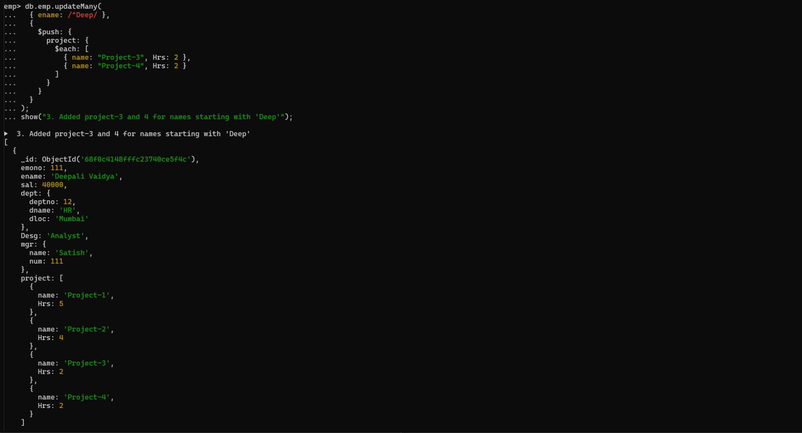

// 4. Add bonus rs 2000 for all employees with salary > 50000
db.emp.updateMany({ sal: { $gt: 50000 } }, { $set: { bonus: 2000 } })

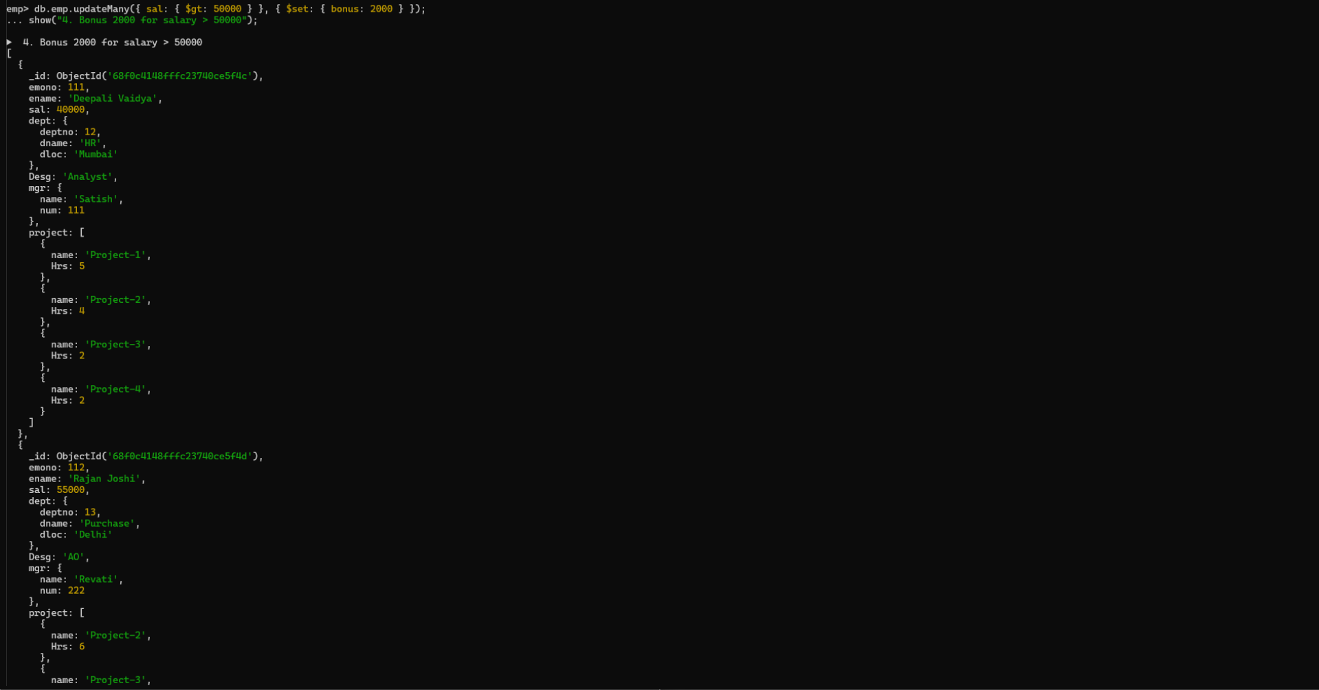

// 5. add bonus 1500 if salary <50000 and > 30000
db.emp.updateMany(
{ sal: { $gt: 30000, $lt: 50000 } },
{ $set: { bonus: 1500 } }
)
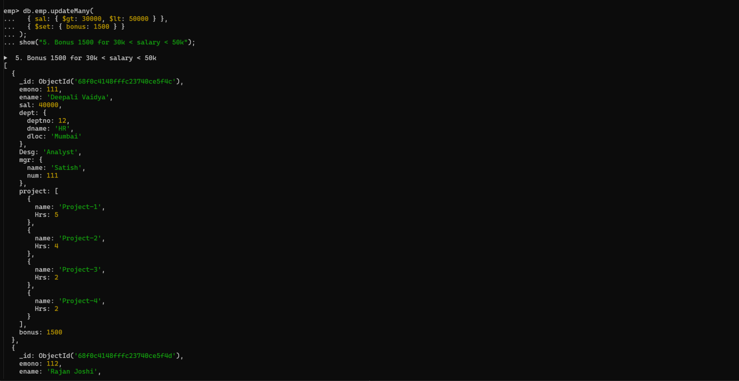

// 6. add bonus 1000 if salary <=30000
db.emp.updateMany({ sal: { $lte: 30000 } }, { $set: { bonus: 1000 } })
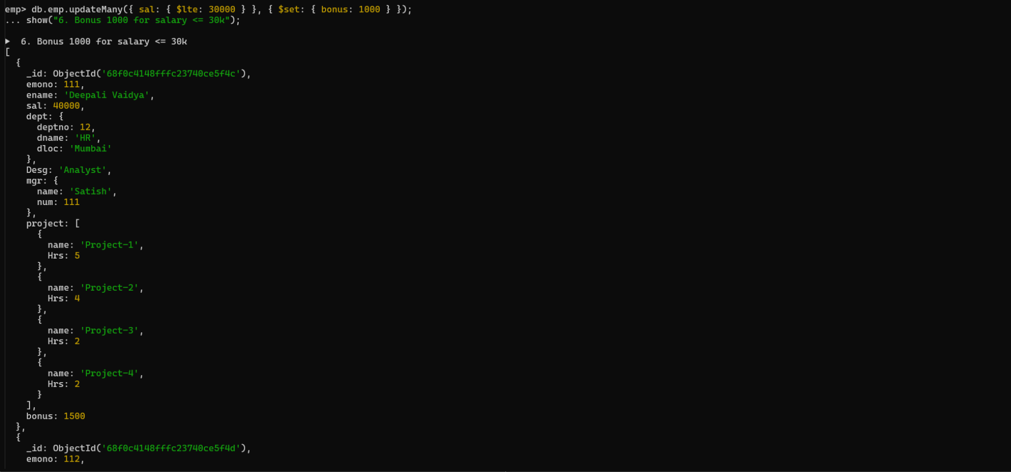

// 7. Change manager name to Tushar for all employees whose manager is currently “satish” And manager number to 3333
db.emp.updateMany(
{ "mgr.name": "Satish" },
{ $set: { "mgr.name": "Tushar", "mgr.num": 3333 } }
)
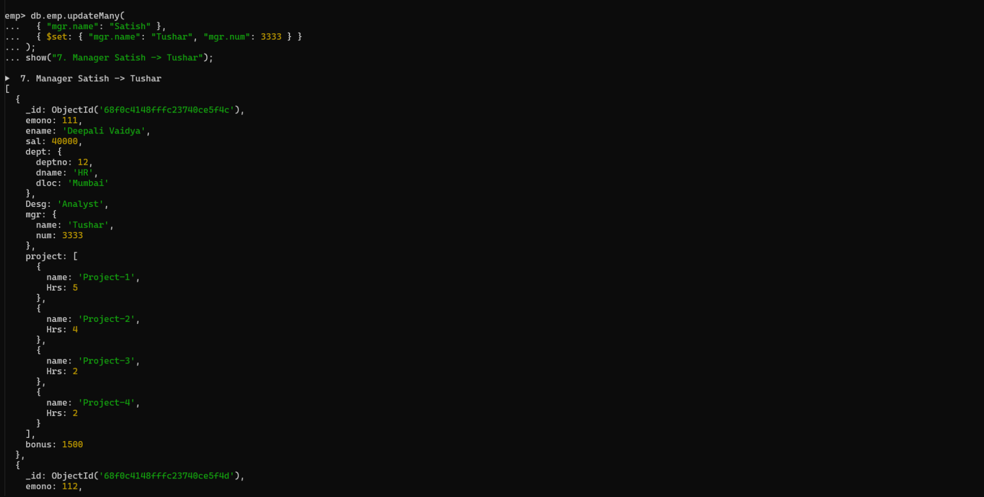

// 8. Increase salary of all employees from “purchase department” by 15000
db.emp.updateMany(
{ "dept.dname": "Purchase" },
{ $inc: { sal: 15000 } }
)
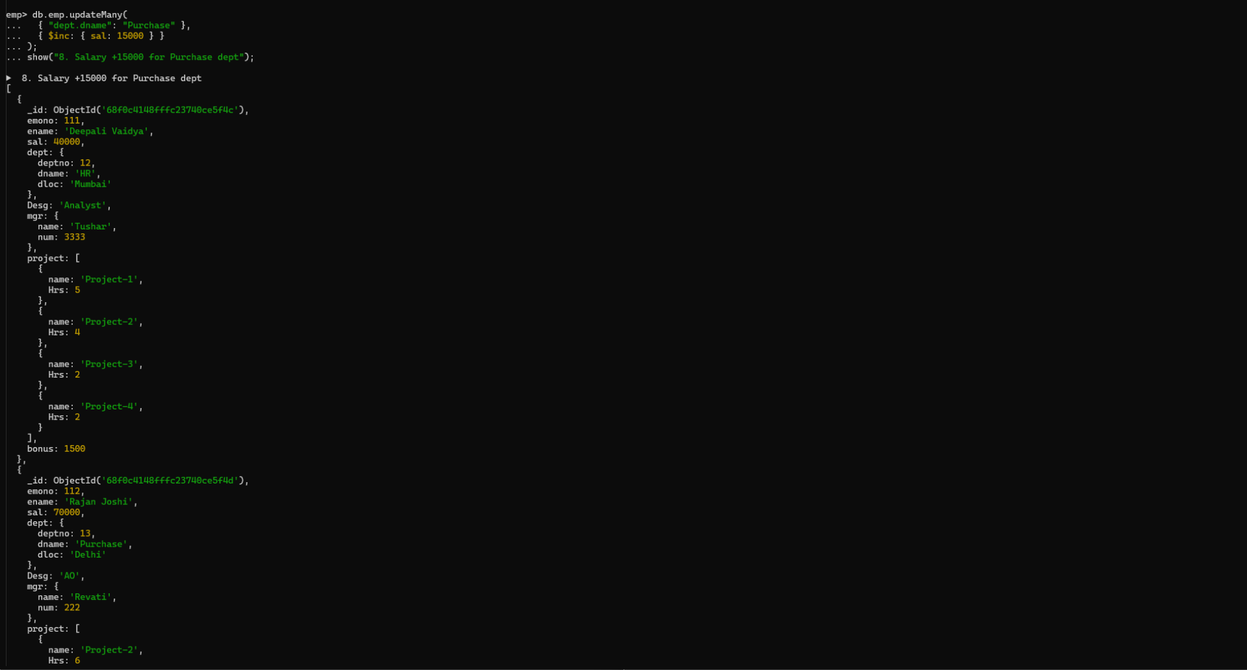

// 9. Decrease number of hrs by 2 for all employees who are working on project-2
db.emp.updateMany(
{ "project.name": "Project-2" },
{ $inc: { "project.$.Hrs": -2 } }
)
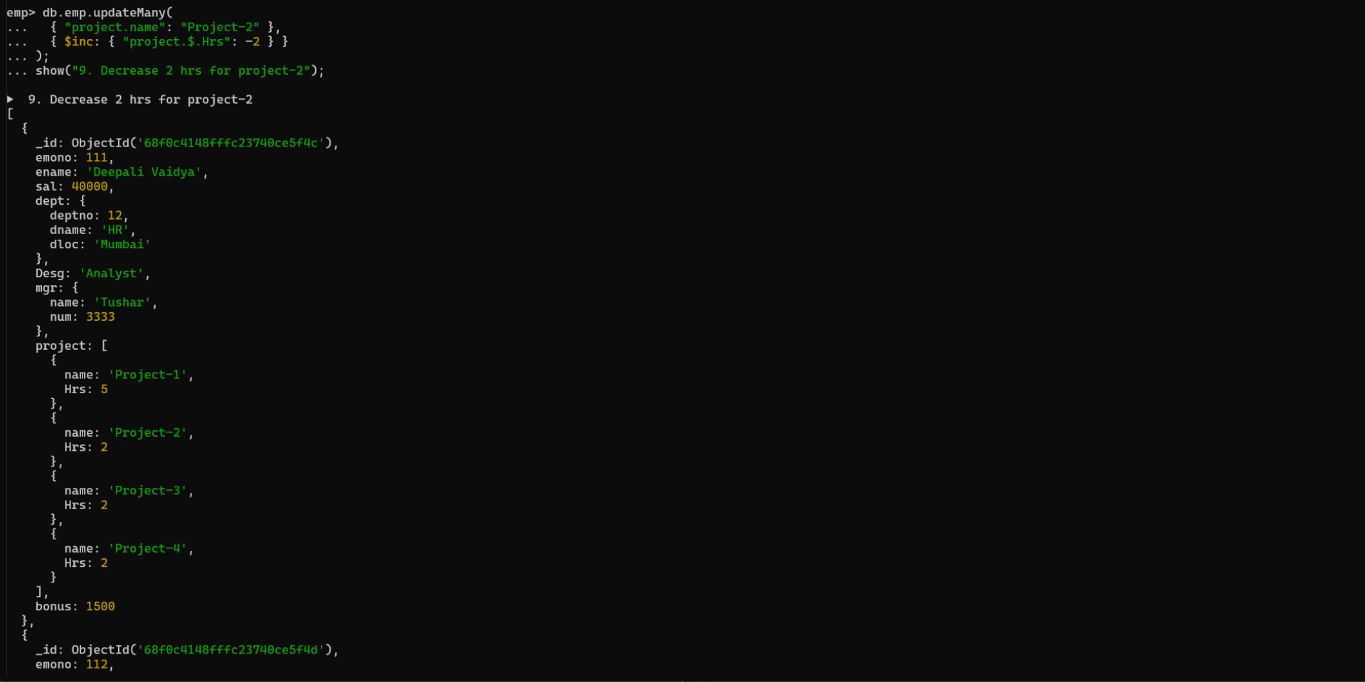

// 10. Delete project-2 from all employee document if they are working on the project for 4
Hrs.
db.emp.updateMany(
{},
{ $pull: { project: { name: "Project-2", Hrs: 4 } } }
)

or
db.Emp.update({},{$pull:{project:{name:'project-2',Hrs:4}}},{multi:true})
or

db.emp.update({},{$pull:{“project:{$elemMatch:{name:”project-
2”,”Hrs”:4}},{multi:true})
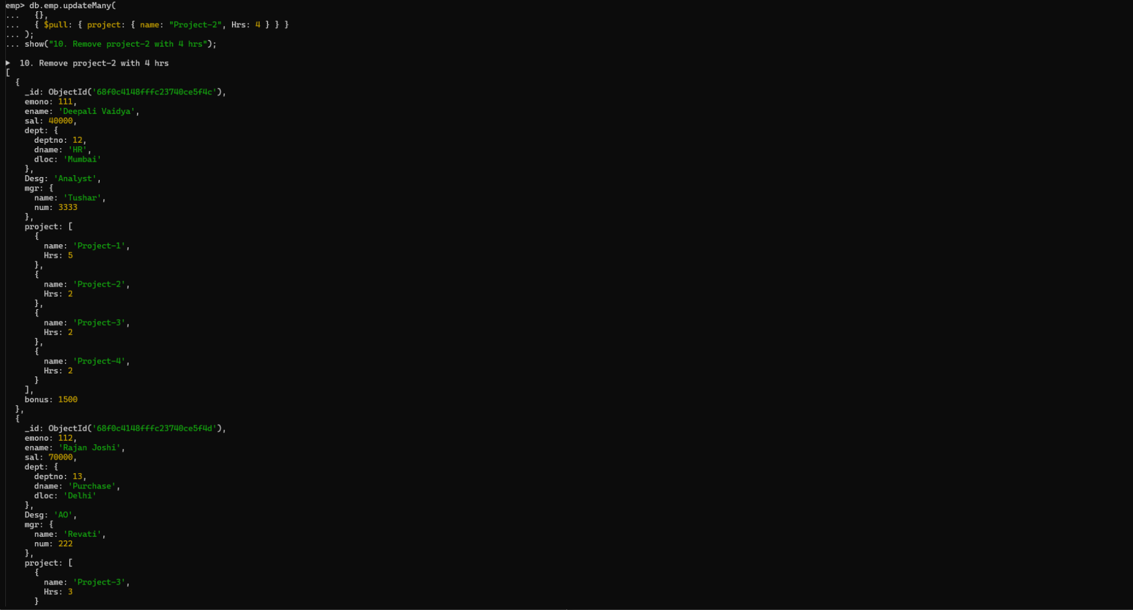
// 11. Change the salary of employees to 10000 only if their salary is < 10000
db.emp.updateMany({ sal: { $lt: 10000 } }, { $set: { sal: 10000 } })


// 12. Increase bonus of all employees by 500 if the bonus is <2000 or their salary is <
20000 or if employee belong to sales department
db.emp.updateMany(
{
$or: [
{ bonus: { $lt: 2000 } },
{ sal: { $lt: 20000 } },
{ "dept.dname": "Sales" }
]
},
{ $inc: { bonus: 500 } }
)
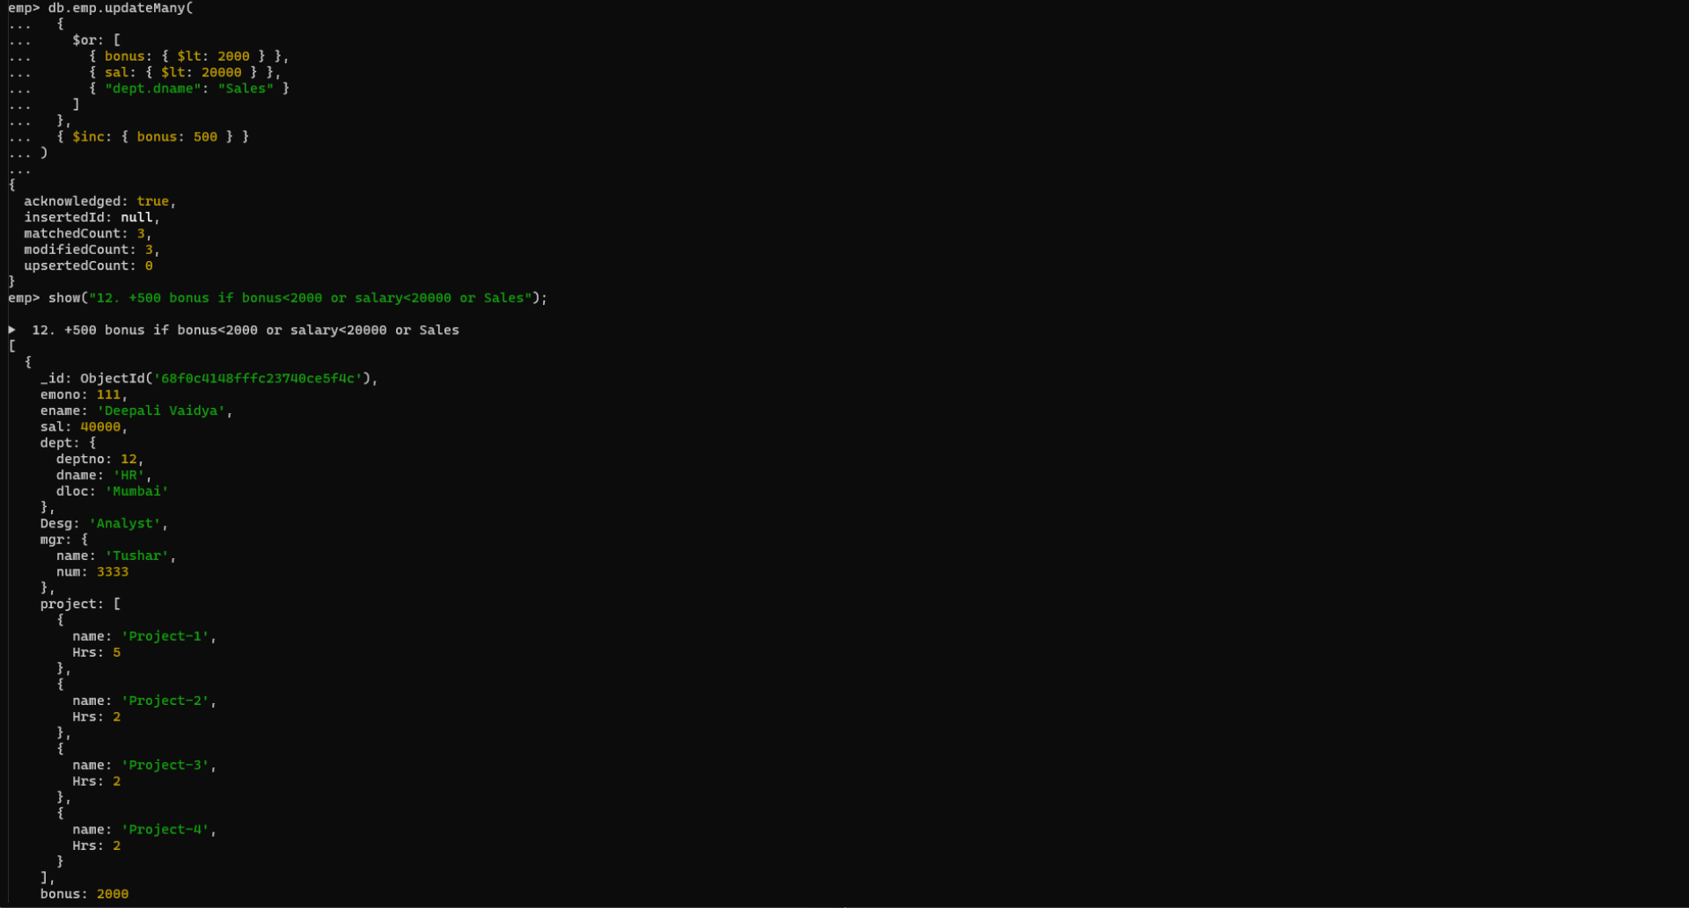

// 13. Add 2 new project at position 2 for all employees with designation analyst or salary is
equal to either 30000 or 33000 or 35000
db.emp.updateMany(
{
$or: [
{ Desg: "Analyst" },
{ sal: { $in: [30000, 33000, 35000] } }
]
},
{
$push: {
project: {
$each: [
{ name: "Project-X", Hrs: 3 },
{ name: "Project-Y", Hrs: 3 }
],
$position: 1
}
}
}
)

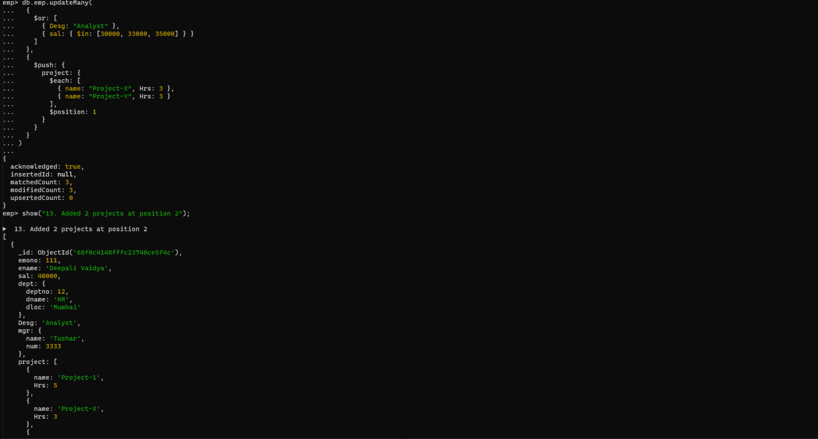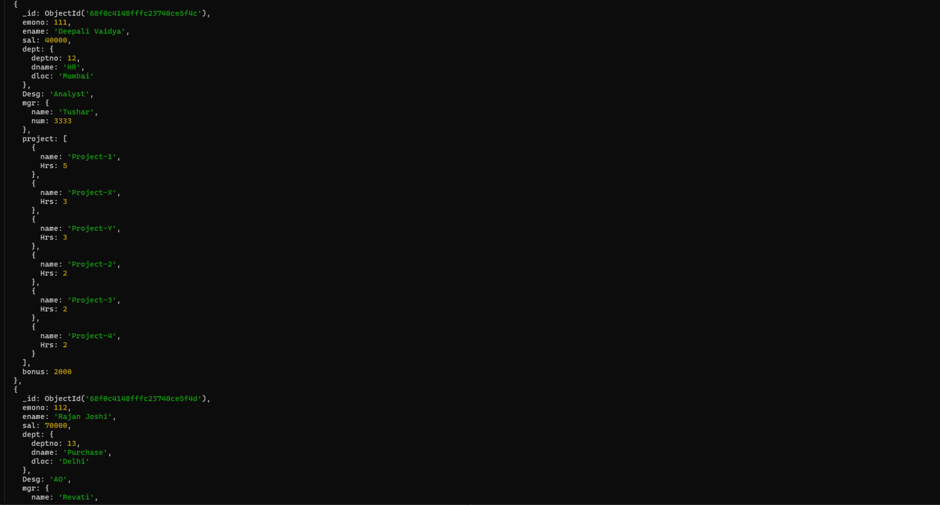
// 14. Delete last project of all employees with department name is “HR” and if the location
is Mumbai
db.emp.updateMany(
{ "dept.dname": "HR", "dept.dloc": "Mumbai" },
{ $pop: { project: 1 } }
)
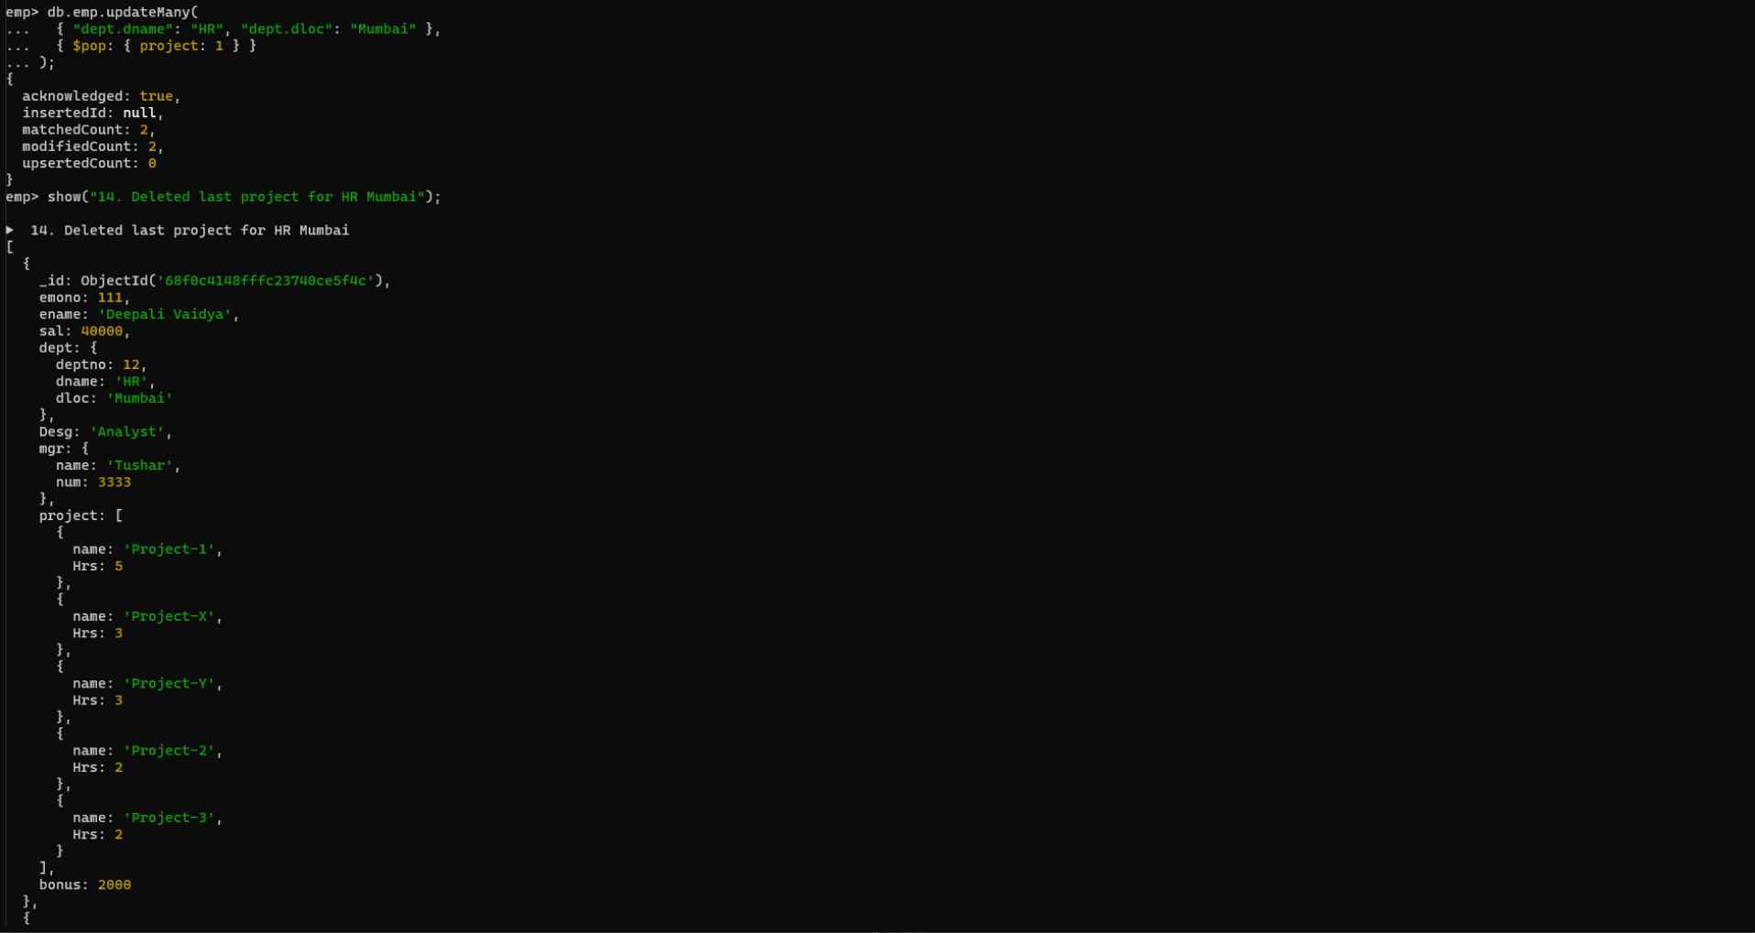

// 15. Change designation of all employees to senior programmer if they are working on
name:”Project-1” for 4 hrs
db.emp.updateMany(
{ project: { $elemMatch: { name: "Project-1", Hrs: 4 } } },
{ $set: { Desg: "Senior Programmer" } }
)
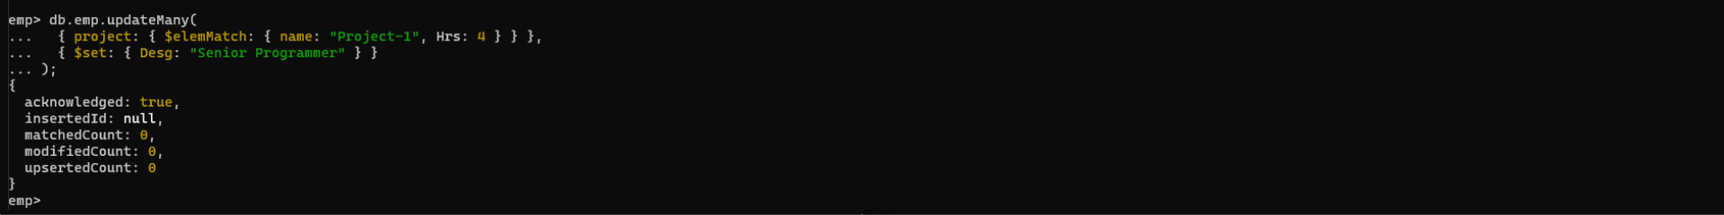

// 16. Add list of hobbies in all employees document whose manager is Rajan or Revati
db.emp.updateMany(
{ "mgr.name": { $in: ["Rajan", "Revati"] } },
{ $set: { hobbies: ["Reading", "Travelling", "Music"] } }
)
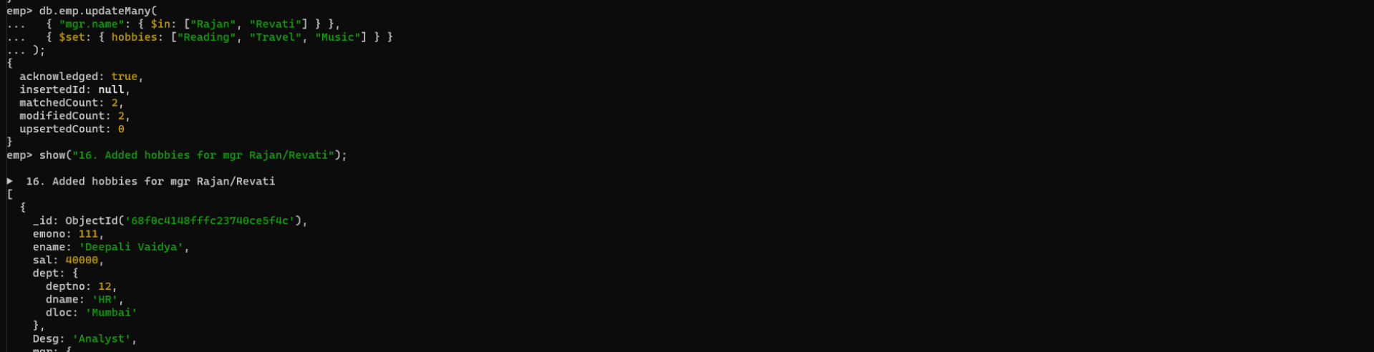
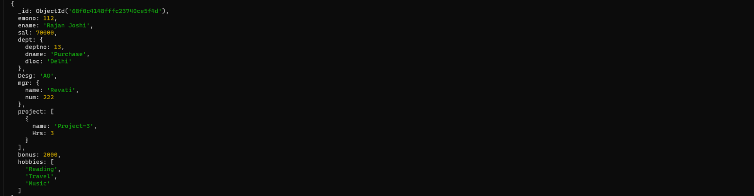

// 17. Add list of skillset in all employee documents who are working on project-4 for 3 hrs
or on project-3 for 4 hrs
db.emp.updateMany(
{
$or: [
{ project: { $elemMatch: { name: "Project-4", Hrs: 3 } } },
{ project: { $elemMatch: { name: "Project-3", Hrs: 4 } } }
]
},
{ $set: { skillset: ["Python", "Java", "SQL"] } }
)
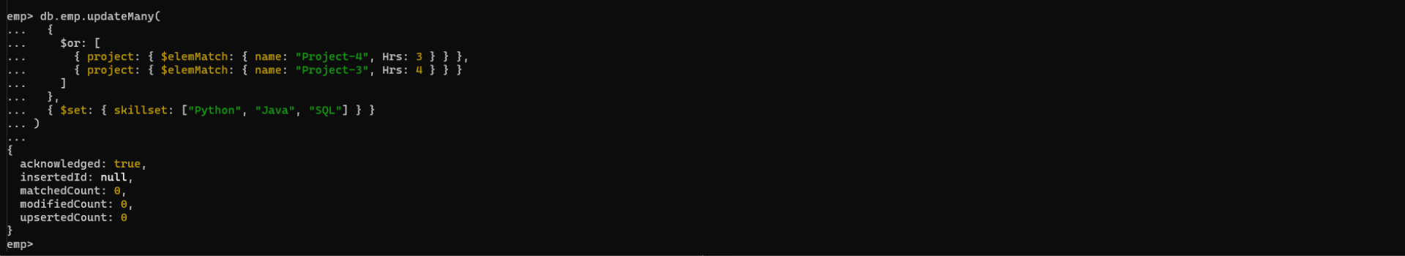

// 18. Add a new hobby as blogging at 3 position in hobbies array for all employess whose
name starts with R or p and ends with j or s
db.emp.updateMany(
{ ename: /^[Rp].*[js]$/i },
{ $push: { hobbies: { $each: ["blogging"], $position: 2 } } }
)
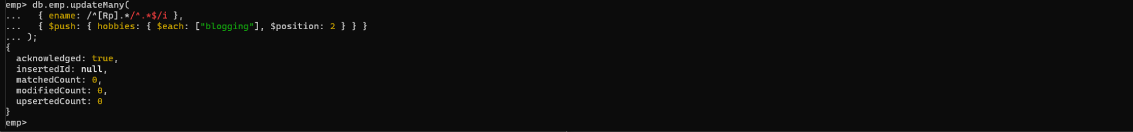

// 19. Increase salary by 10000 for all employees who are working on project-2 or project-3
or project-1
db.emp.updateMany(
{ "project.name": { $in: ["Project-1", "Project-2", "Project-3"] } },
{ $inc: { sal: 10000 } }
)
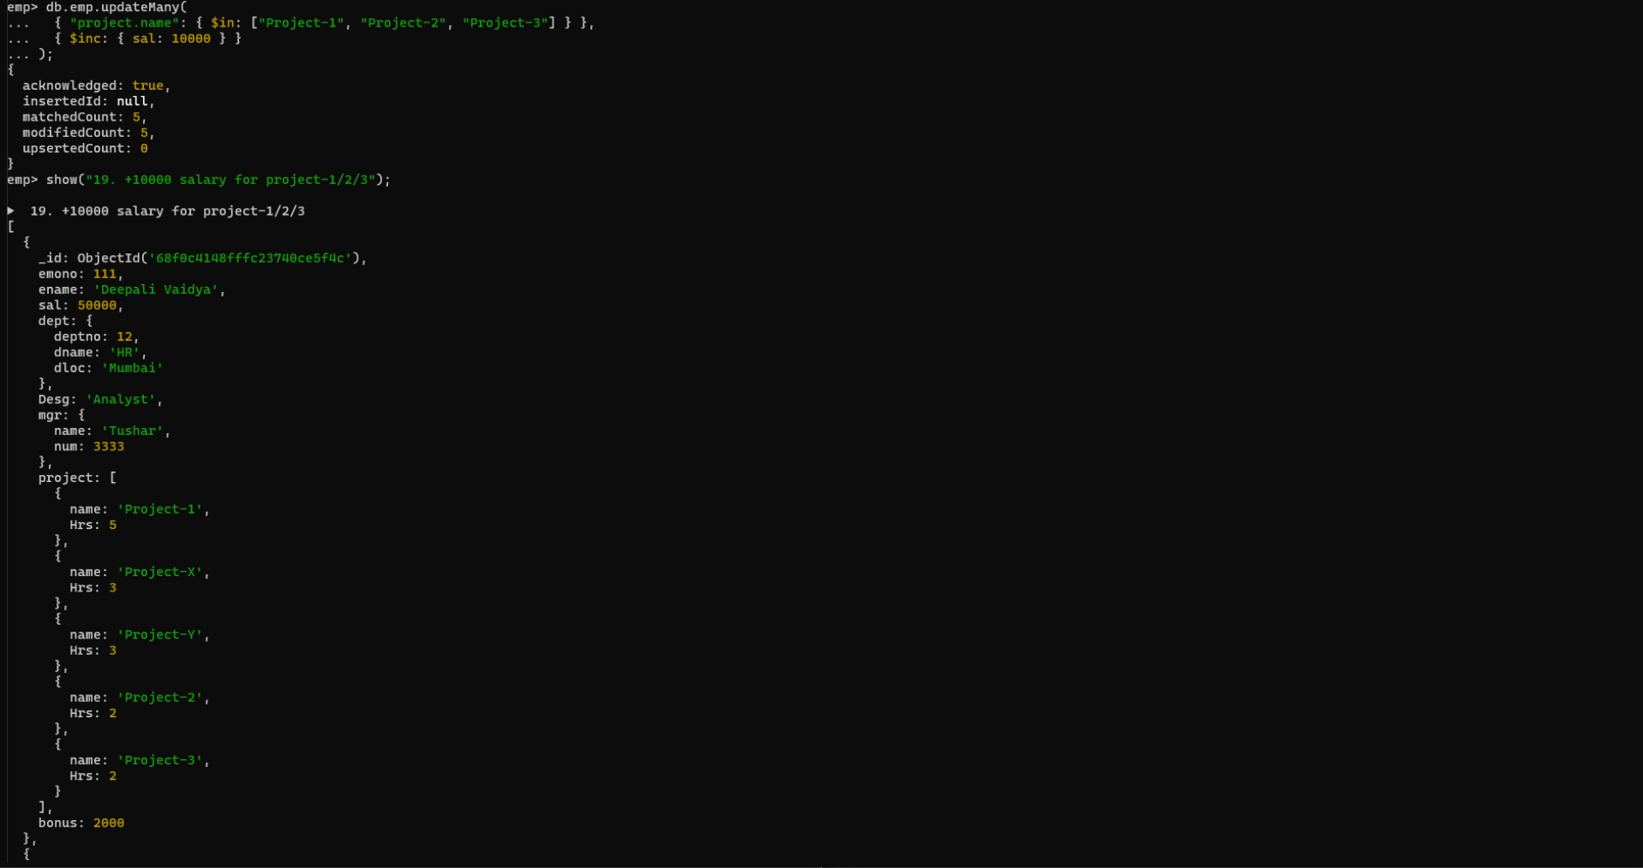

// 20. Decrease bonus by 1000 rs And increase salary by 1000rs for all employees whose
department location is Mumbai
db.emp.updateMany(
{ "dept.dloc": "Mumbai" },
{ $inc: { bonus: -1000, sal: 1000 } }
)
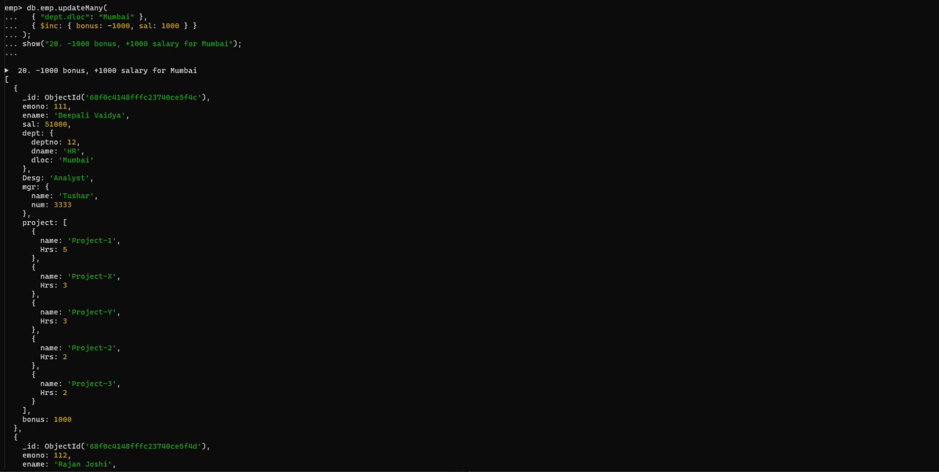

// 21. Remove all employees working on project-1
db.emp.deleteMany({ "project.name": "Project-1" })
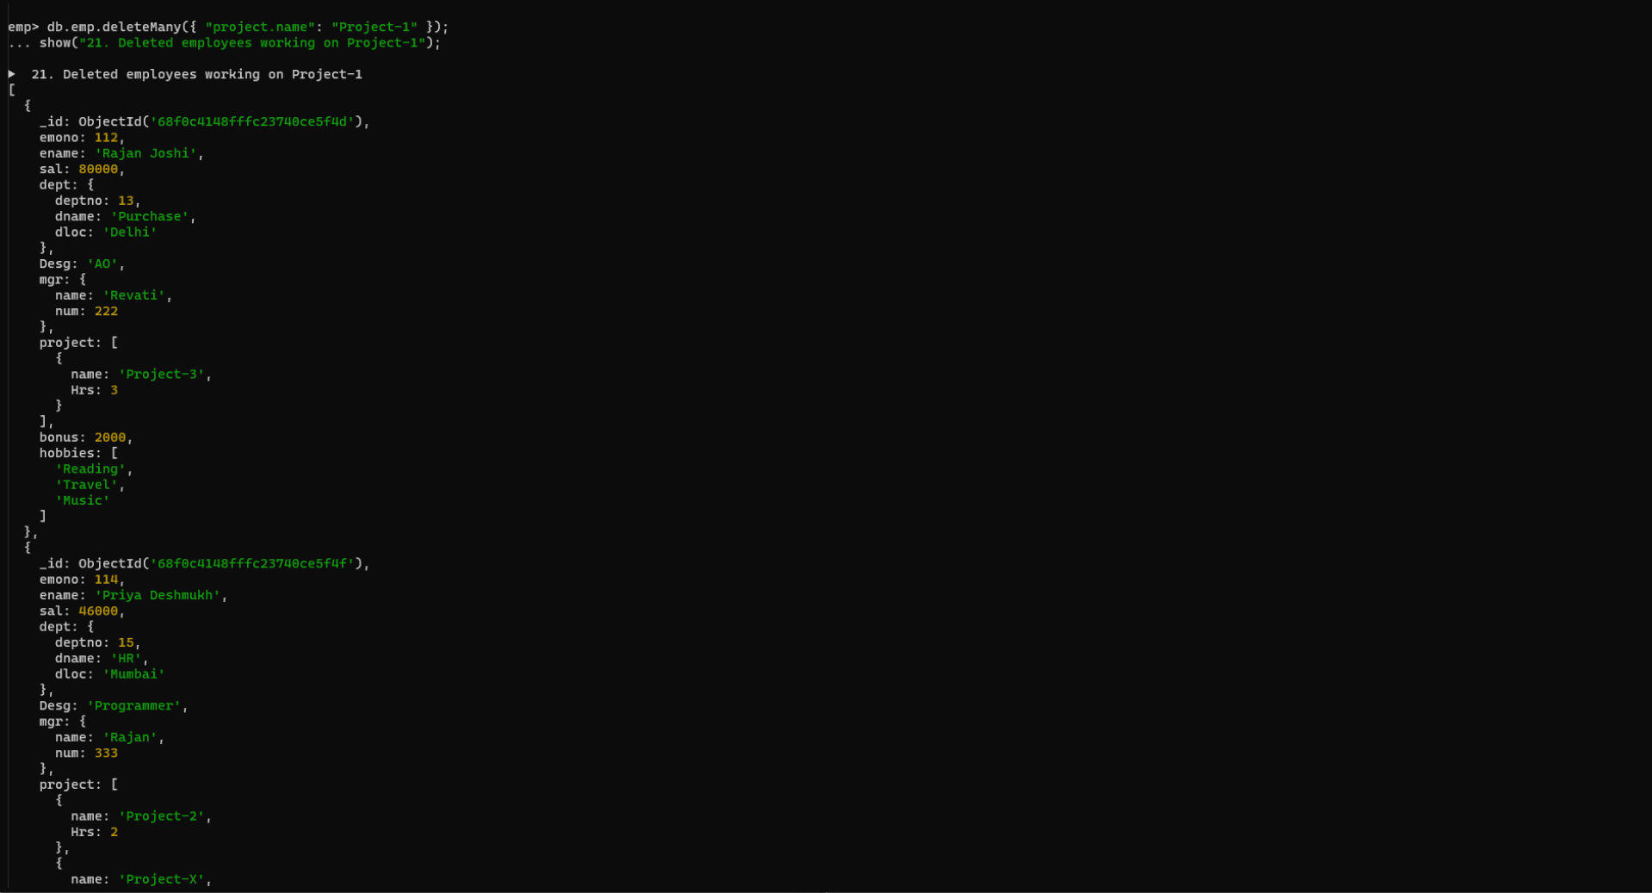

// 22. Replace document of employee with name “Deepak to some new document
db.emp.replaceOne(
{ ename: "Deepak Pawar" },
{
emono: 200,
ename: "Deepak Desai",
sal: 50000,
dept: { deptno: 20, dname: "Finance", dloc: "Pune" },
Desg: "Developer",
mgr: { name: "Tushar", num: 3333 },
project: [{ name: "Project-New", Hrs: 5 }]
}
)
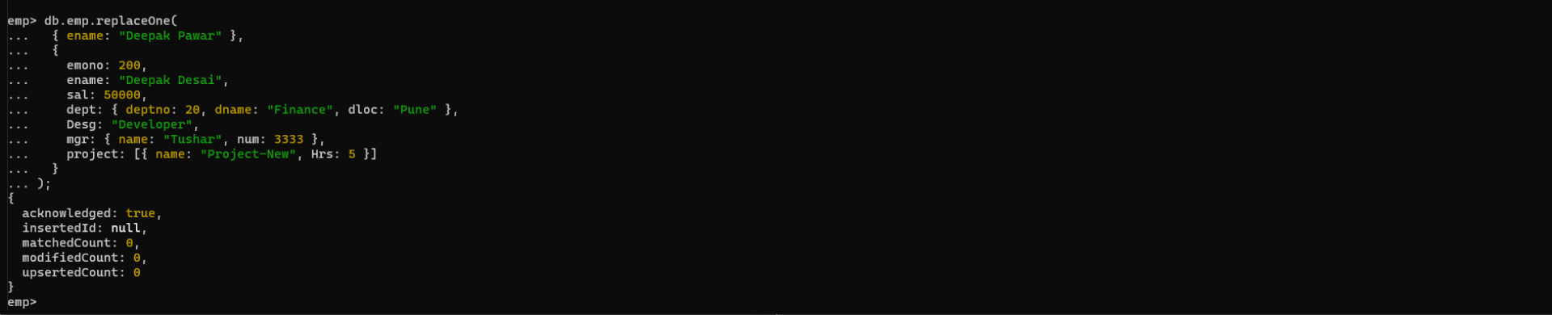

//23. Change skill python to python 3.8 for all employees if python is there in the skillset
db.emp.updateMany(
{ skillset: "Python" },
{ $set: { "skillset.$": "Python 3.8" } }
)
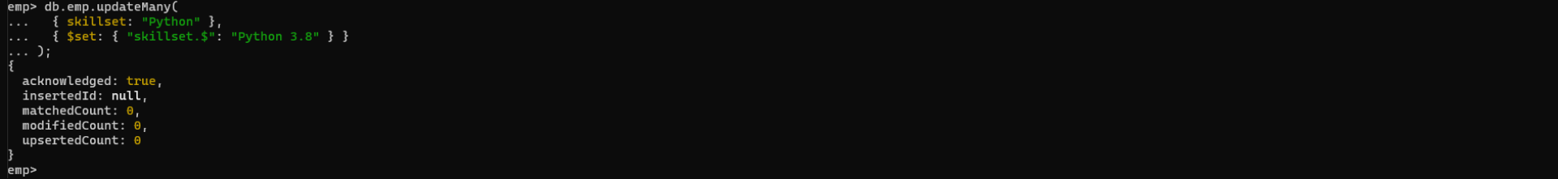

// 24. Add 2 skills MongoDb and Perl at the end of skillset array for all employees who are
working at Pune location
db.emp.updateMany(
{ "dept.dloc": "Pune" },
{ $push: { skillset: { $each: ["MongoDB", "Perl"] } } }
)
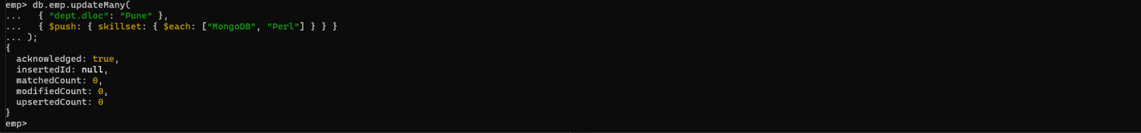

// 25. Delete first hobby from hobby array for all employees who are working on project-1
or project-2
db.emp.updateMany(
{ "project.name": { $in: ["Project-1", "Project-2"] } },
{ $pop: { hobbies: -1 } }
)


//26. Delete last hobby from hobbies array for all employees who are working on project
which is at 2 nd position in projects array for 4 hrs
db.emp.updateMany(
{ "project.1.Hrs": 4 },
{ $pop: { hobbies: 1 } }
)
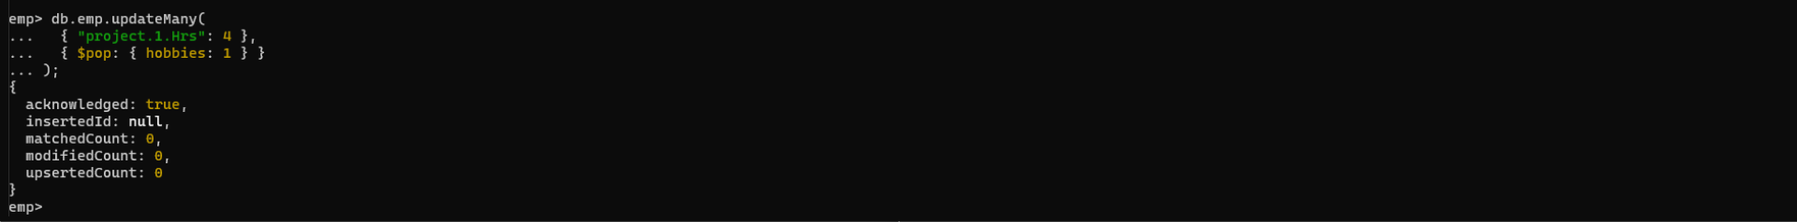

// 27. Add 2 new projects at the end of array for all employees whose skillset contains Perl
or python
db.emp.updateMany(
{ skillset: { $in: ["Perl", "Python", "Python 3.8"] } },
{
$push: {
project: {
$each: [
{ name: "Project-Extra1", Hrs: 2 },
{ name: "Project-Extra2", Hrs: 3 }
]
}
}
}
)
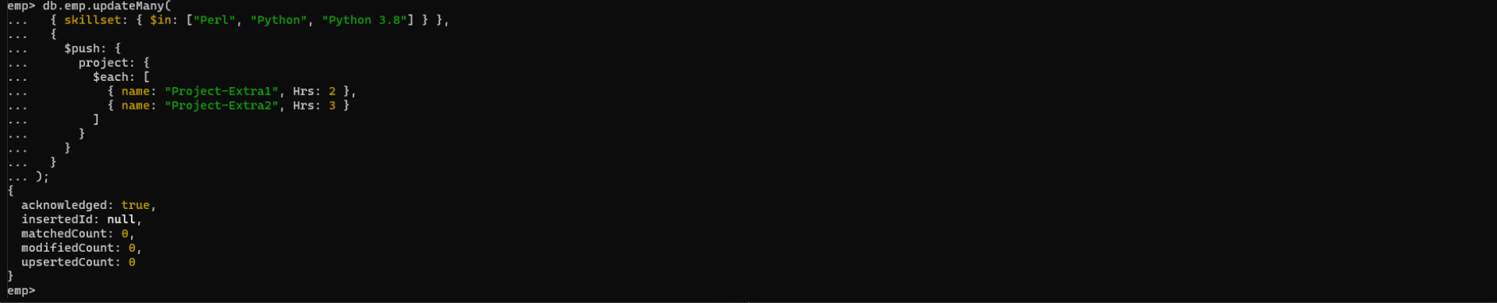

// 28. Change hrs to 6 for project-1 for all employees if they working on the project-1 for <
6 hrs. otherwise keep the existing value.
db.emp.updateMany(
{ project: { $elemMatch: { name: "Project-1", Hrs: { $lt: 6 } } } },
{ $set: { "project.$.Hrs": 6 } }
)
